What baho has done:

This week, I was supposed to implement the band bass filters that were designed previous week, however, as a company, we decided to go with Tiva (Texas instrument microprocessor evaluation board) or an Arduino to count the frequencies of the input signal due to the fact that the analog filters will be too sensitive to enviromental effects and implementing them correctly will be quite challanging. Therefore, this week, I worked on sending different pulses with different inputs ove FM channel that I was implementing. First, I have managed to use Rasperry Pi’ GPIO pins as a input buttons using WiringPi library and depending on the states, I have managed to send specific sine waves with different frequencies. In other words, we did manage to send commands to wireless location. Further opmization will be done in the transmitter program in the following week. On the other hand, I made an better antenna (it was a simple jumper wire before) using a think satellite receiver coaxial cable to achieve even better range and noise performance. The new antenna can be seen in figure XXX. Testing on the new antenna, I observed that the signal power is way above the level it was before. I believe that with this antenna design, we won’t need an amplifier to boost the signal. However, the antenna can be further imroved in the following weeks.

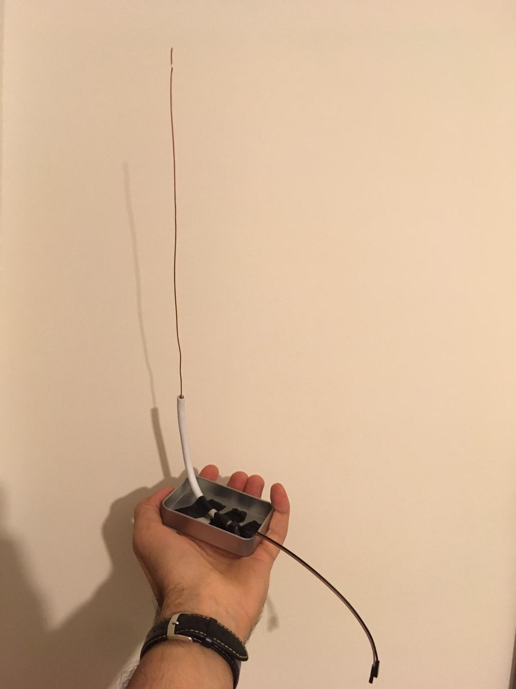

Figure 1 The antenna

NEXT WEEK:

Next week, we will try to blink a LED at a remote location using complete communicatiıon link that is Raspberry pi, FM radio and Tiva or Arduino.

Also, for the image transfer task, we will try a new drone kit that we had ordered.